1. Look at the database represented in the E-R diagram named 'E-R diagram – carpooling service company' (on Omnivox – also present in today's review of the last course) and:

• Formulate ten queries that might be made to that database.

* Insert into user values (“1234”,”DavinderSingh”,”Kharoud”);
* Select * from user;
* Select FirstName from user where UserID=1234;
* Insert into Route values (‘4321’,’45.496563’,’-73.786004’,’21:20’,12:40’);
* Select timestamp_start from Route where RouteId=4321;
* Select FirstName,LastName from user where userId=1234;
* Select min(salary) as salary from Employee;
* Select max(salary) as salary form Employee;
* Update user set firstName=”Sunny” where userid=1234;
* Select avg(salary) from Employee;

• Identify the integrity constraints that have to be respected.

* Salary in Employee and year in vehicle table must be integer.
* TimeStamp_start,TimeStamp_end,Date_hired,Date_fired must be TimeDate data type.
* UserId,routeid,vehicleId,RequestId must be varchar.
* FirstName,LastName of same userId must be same for User and Employee table.

• Put each entity from the diagram in a table (turning it into a relation) and verify that it respects the first, second and third Normal Forms. If it doesn't, make the necessary changes so that it does.

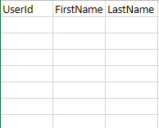

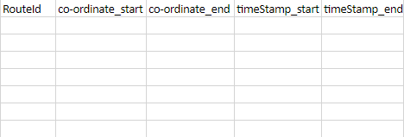

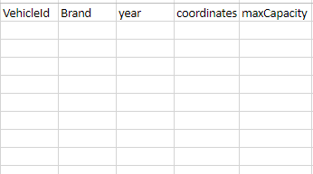

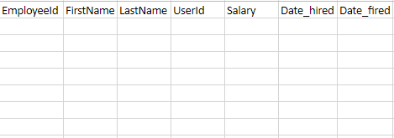

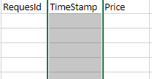

2.For the E-R diagram above:

• Identify the integrity constraints that have to be respected.

* ArticleId,ResearchId,virusId,reviewJournalId must be VARCHAR.
* ContactNumber must be type int in researchContract.
* StartDate ,EndDate must be TimeDate type.
* ContactNumber must be of range 9 digits.

• Put each entity from the diagram in a table (turning it into a relation) and verify that it respects the first, second and third Normal Forms. If it doesn't, make the necessary changes so that it does.

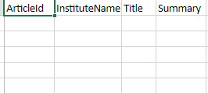

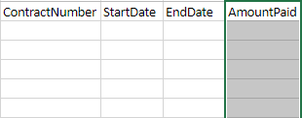

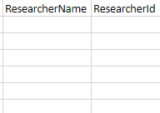

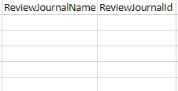

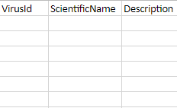

3. An online movie provider rents movies and movie downloads. Each movie is categorized by gender. For a movie, we know its director and the main actors. The movies are always available to download, and some movies are also available on one or several DVDs. Each DVD can be rented for a period of 7 days at the most. The movie provider has customers; for each customer, we have a first name, a last name, an address, a phone number and/or an e-mail address. For each movie, we have its title, its length, its year of filming, and a summary. The directors and actors are each identified by their social insurance number, first name, last name, and date of birth. For the situation above, please:

• Draw an E-R diagram which represents the system described.

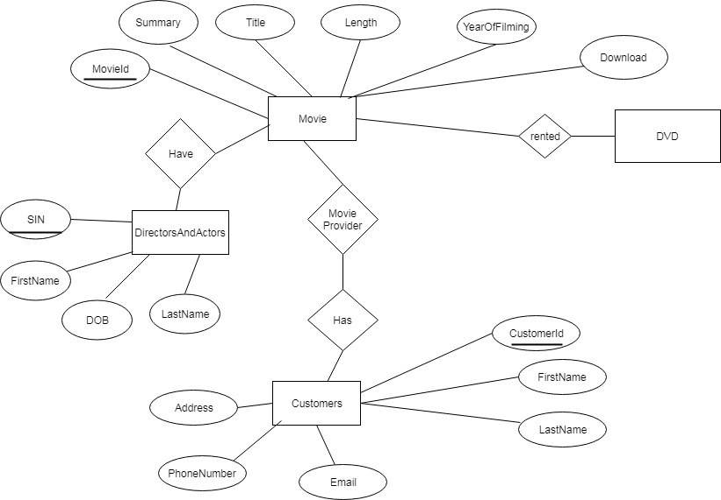

• Specify the integrity constraints that have to be respected.

* MovieId,CustomerId should have VARCHAR.
* SIN,PhoneNumber must be int.
* PhoneNumber must be 9 digit long only.
* Email should be in VARCHAR.

• Put each entity from the diagram in a table (turning it into a relation) and verify that it respects the first, second and third Normal Forms.

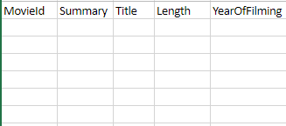

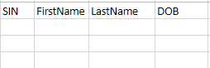

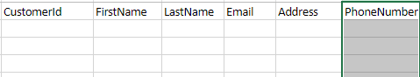

4. For every table presented, make the necessary corrections to put it in the Third Normal Form:

1:

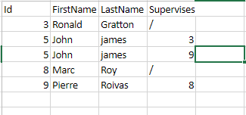

2:

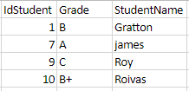

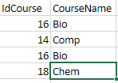

3:

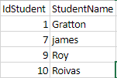

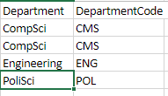

5:

a) Name 4 reasons why SQL transactions are considered to be reliable.

1. Atomicity
2. Consistency
3. Isolation
4. durability

b) For each of those 4 reasons, briefly explain what it means.

1. Atomicity: an atomic transaction cannot be divided in subtransactions, it is either completed, or hasn't begun at all.
2. Consistency: if there is an error during a transaction, it is automatically rolled back to ensure that the system stays in a consistent state.
3. Isolation: each transaction accesses data as if it is the only transaction running on the system , so it cannot use data which may have changed after the transaction started.
4. Durability: once a transaction is completed, all the changes it made to the system are permanent.

6: Name two integrity constraints and explain each of them.

1. Domain Constraint: it is by restricting what type of values can be entered for an attribute and also by restricting what range of values an attribute can take.
2. Referential Integrity Constraint:if some attributes appear for a tuple in a relation, and they reappear for a tuple in another relation, those attributes must have the same values.